|  |  |  |  |  |
| --- | --- | --- | --- | --- |
| ID (Ferr : H<30, F<13) | Cut-off point | sensitivity | specificity | AUC |
| CCMH (gr/dl) | 33,25 | 74,4 | 63,1 | 0,725 |
| TGMH (pg) | 28,45 | 76,1 | 63,4 | 0,750 |
| Ret-Hb (pg) | 32,85 | 70 | 60,5 | 0,690 |
| VGM (fl) | 84,85 | 69,9 | 56,1 | 0,683 |
| RDW (fl) | 40,25 | 67,5 | 56,6 | 0,649 |
| RDW-CV (%) | 12,85 | 74,2 | 65,1 | 0,768 |
| IRF (%) | 10,85 | 62,3 | 55,0 | 0,625 |
| HRF (%) | 1,45 | 62,1 | 59,5 | 0,656 |

**\*Summary tables of the diffèrent sensitivity and specificity of the diffèrent parameters :**

|  |  |  |  |  |
| --- | --- | --- | --- | --- |
| AIS (Ferr : <12) | Cut-off point | sensitivity | specificity | AUC |
| CCMH (gr/dl) | 31,95 | 90,7 | 63,1 | 0,874 |
| TGMH (pg) | 26,95 | 91,1 | 75,3 | 0,909 |
| Ret-Hb (pg) | 31,85 | 81,5 | 75,5 | 0,839 |
| VGM (fl) | 83,55 | 80,3 | 75,2 | 0,846 |
| RDW (fl) | 41,05 | 75,0 | 64,5 | 0,759 |
| RDW-CV (%) | 13,25 | 91,7 | 81,3 | 0,930 |
| IRF (%) | 11,65 | 70,2 | 37,1 | 0,718 |
| HRF (%) | 1,75 | 69,0 | 69,8 | 0,749 |

|  |  |  |  |  |
| --- | --- | --- | --- | --- |
| LIS (Ferr : <50) | Cut-off point | sensitivity | specificity | AUC |
| CCMH (gr/dl) | 33,75 | 63,0 | 60,4 | 0,655 |
| TGMH (pg) | 29,25 | 61,6 | 59,7 | 0,639 |
| Ret-Hb (pg) | 33,25 | 65,3 | 52,1 | 0,611 |
| VGM (fl) | 86,05 | 59,3 | 50,5 | 0,580 |
| RDW (fl) | 40,25 | 60,3 | 59,8 | 0,617 |
| RDW-CV (%) | 12,65 | 65,3 | 58,5 | 0,671 |
| IRF (%) | 10,05 | 59,6 | 45,6 | 0,540 |
| HRF (%) | 1,25 | 58,1 | 49,9 | 0,553 |

**\*IRON DEFICIENCY ( Ferr : H<30, F<13) :**

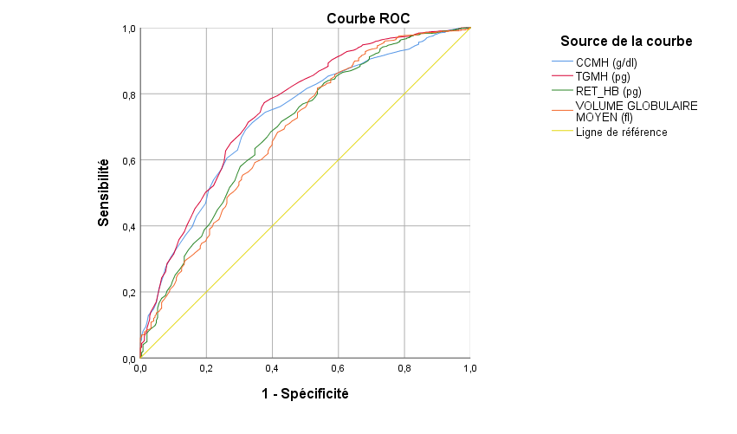

|  |  |  |  |
| --- | --- | --- | --- |
|  | | | |
| **Variable(s) de résultats tests** | **Zone** | **Erreur standarda** |
|
| **CCMH (g/dl)** | 0,725 | ,017 |
| **TGMH (pg)** | 0,750 | ,017 |
| **RET_HB (pg)** | 0,690 | ,019 |
| **VOLUME GLOBULAIRE MOYEN (fl)** | 0,683 | ,019 |

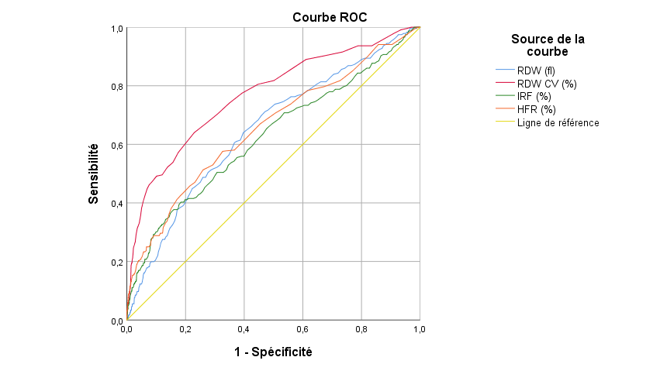

|  |  |  |
| --- | --- | --- |
| **Variable(s) de résultats tests** | **Zone** | **Erreur standarda** |
|
| **RDW (fl)** | 0,649 | ,019 |
| **RDW CV (%)** | 0,768 | ,018 |
| **IRF (%)** | 0,625 | ,021 |
| **HFR (%)** | 0,656 | ,020 |
|  | | | |
|  | | | |
|  | | | |

**\*Absence of iron stocks (Ferr : <12)**

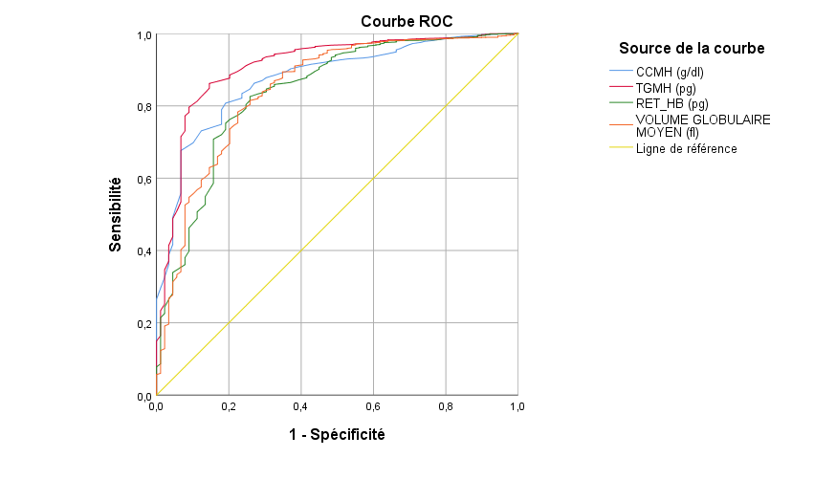

|  |  |  |  |
| --- | --- | --- | --- |
|  | | | |
| **Variable(s) de résultats tests** | **Zone** | **Erreur standarda** |
|
| **CCMH (g/dl)** | 0,874 | ,017 |
| **TGMH (pg)** | 0,909 | ,017 |
| **RET_HB (pg)** | 0,839 | ,023 |
| **VOLUME GLOBULAIRE MOYEN (fl)** | 0,846 | ,023 |

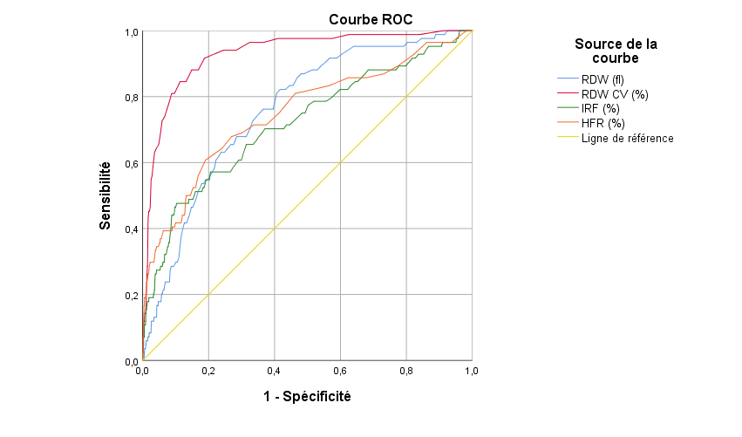

|  |  |  |
| --- | --- | --- |
| **Variable(s) de résultats tests** | **Zone** | **Erreur standarda** |
|
| **RDW (fl)** | ,759 | ,024 |
| **RDW CV (%)** | ,930 | ,014 |
| **IRF (%)** | ,718 | ,032 |
| **HFR (%)** | ,749 | ,031 |
|  | | | |
| **\*Low iron stocks (Ferr : <50) :** | | | |
| |  |  |  | | --- | --- | --- | | **Variable(s) de résultats tests** | **Zone** | **Erreur standarda** | | | **CCMH (g/dl)** | 0,655 | ,012 | | **TGMH (pg)** | 0,639 | ,013 | | **RET_HB (pg)** | 0,611 | ,013 | | **VOLUME GLOBULAIRE MOYEN (fl)** | 0,580 | ,013 | |  | | | | |  | | | | | |  |  |  | | --- | --- | --- | | **Variable(s) de résultats tests** | **Zone** | **Erreur standarda** | | | **RDW (fl)** | 0,617 | ,013 | | **RDW CV (%)** | 0,671 | ,013 | | **IRF (%)** | 0,540 | ,014 | | **HFR (%)** | 0,553 | ,014 | |  | | | | |  | | | | |  | | | | | | | | | | | |